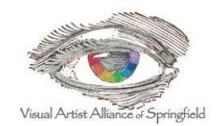
“Promoting artists and art through exhibitions, education, and fellowship.”

May 2024 Newsletter

President’s Letter:

Hello Artists!

Spring is here and there are lots of outdoor activities and art festivals. See you at Artsfest on Historic Walnut Street on May 4 and May 5. Ann Kynion and I are volunteering, and Teresa Fry and Janelle Patterson are exhibiting, among many others.

We have a new Board member, Ann Gunion. Welcome Ann. We now have a full Board. Thanks everyone for volunteering.

We are working to get our works displayed on the new website that Victoria Johnson has established. Her husband, Randy Henderson, will be speaking with us at our May 2 meeting about the best way to photograph our art, and Linda Kirchner will be standing by to help anyone to draft our bio and artist’s statement. Each member can submit up to four photos of their art and a bio and artist’s statement to Victoria at visArtsgf@gmail.com. She will help create the members’ pages.

We have a tentative date of August 7 for our lunch at Nearly Famous Deli and Pasta House. We are replacing our summer picnic with this lunch opportunity to thank Nearly Famous for its support of our members.

See you Thursday, May 2 at 11 a.m. at the Springfield Art Museum.

Sharon

May 2024 Meeting
Preparing to submit artwork online for an exhibition or contest can be a challenge for some of us right-brained thinkers or those who aren’t as tech-savvy. Our May meeting should be helpful for all artists who participate in exhibits or who wish to display their art online.
Our speaker for our May 2 meeting, starting at 11 a.m. at The Springfield Art Museum, is Randy Henderson. Randy’s website is linked in the black button below.
Randy specializes in real estate and architecture photography, which involves a lot of photography for online galleries and websites. Importantly for us, he is also the husband of our website guru and local digital collage artist, Victoria Johnson.
Randy Henderson

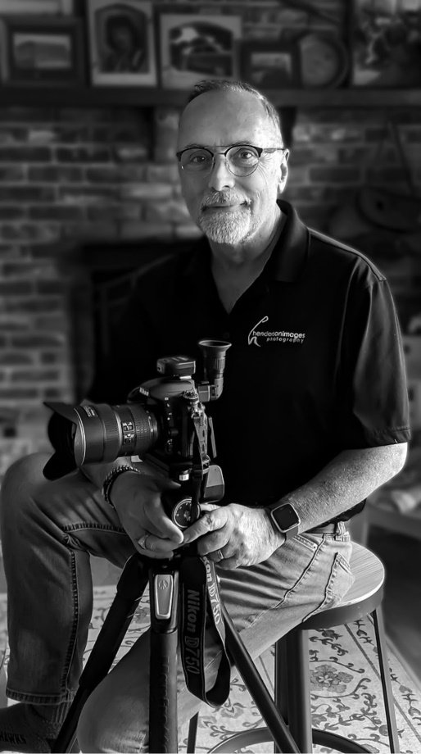
Additionally, VAAS member Linda Kirchner has volunteered to help members who are preparing bios and artist statements.
This meeting should be a great opportunity to learn the skills and understand the terminology of online submission instructions.

If you have a piece of art that you would like to share or would like suggestions, please bring it to the meeting. We plan to have time for show and share for our members.

Current and Upcoming Exhibits
“Homage to a Master”
Last month, we hanged members’ art for the 5th Floor show at Juanita K. Hammons. Congratulations to Teresa Fry (Best of Show for “This Kiss”), Renee Eiffert (Best Theme for “Pablo’s Guitar”), and Andrea Hellman (Honorable Mention for “The Merry Chickens of Springfield”). A big thank you to our judge, Farley Lewis. The exhibit remains up through June 6.

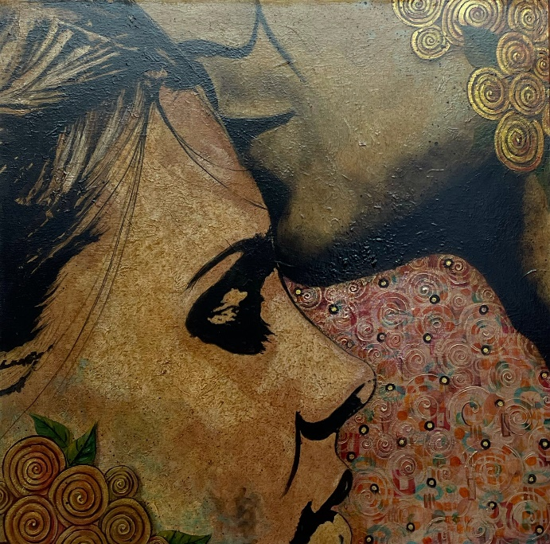
Teresa Fry, “This Kiss”
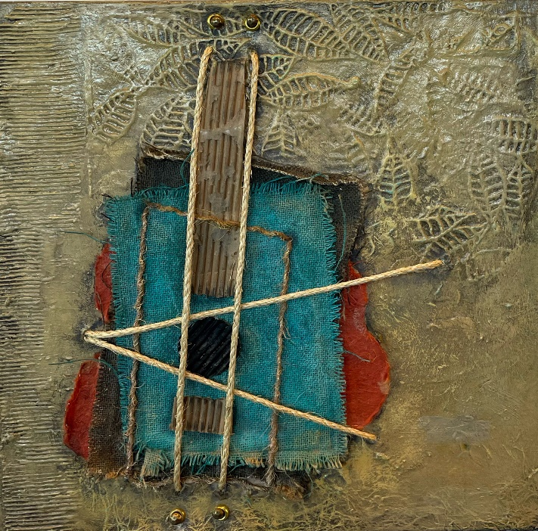
Renee Eiffert, “Pablo’s Guitar”
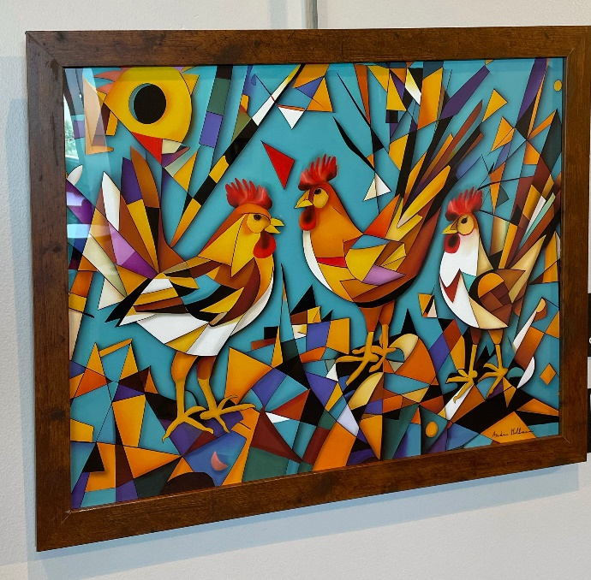
Andrea Hellman, “The Merry Chickens of Springfield”
4th Floor Show
Donna Rustin and Sharon Cates share the space on the 4th Floor of Juanita K. Hammons. If you haven’t seen that joint exhibit, make sure to stop by.
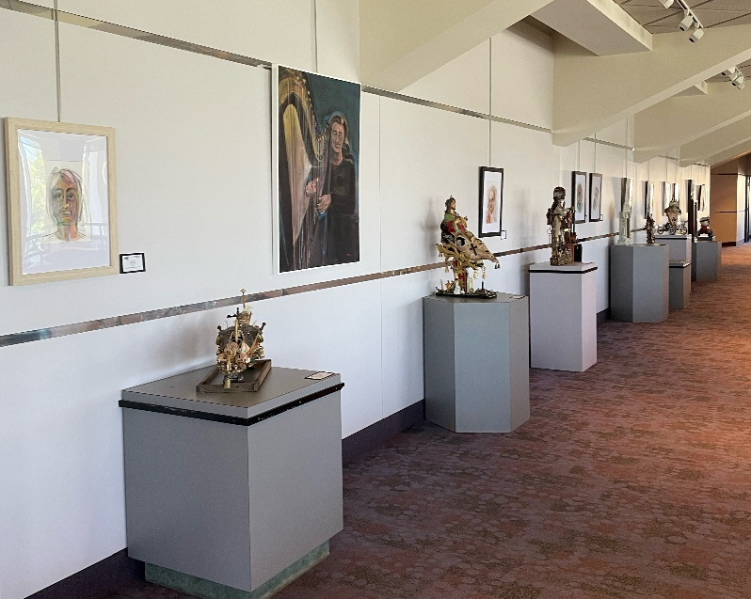
Part of the 4th Floor Show
Nearly Famous Deli
A new show is up at Nearly Famous Deli and Pasta House, featuring VAAS members Nancy Dornan and Ann Marie Rausch. That show remains up through June 8.
ERPCA
Elliott Robinson held a closing reception on April 23 in recognition of the VAAS members that participated in the ERPCA show. A big thank you to ERPCA for its support of art and VAAS. Here are a few photos of some of the members and their art at ERPCA.
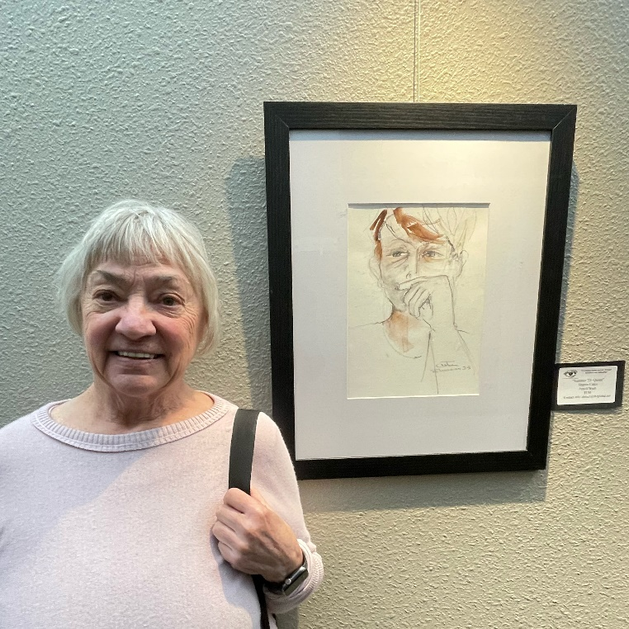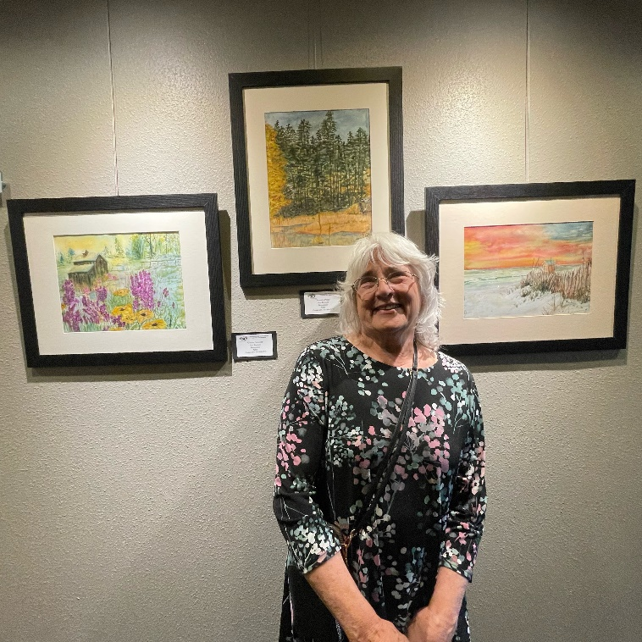
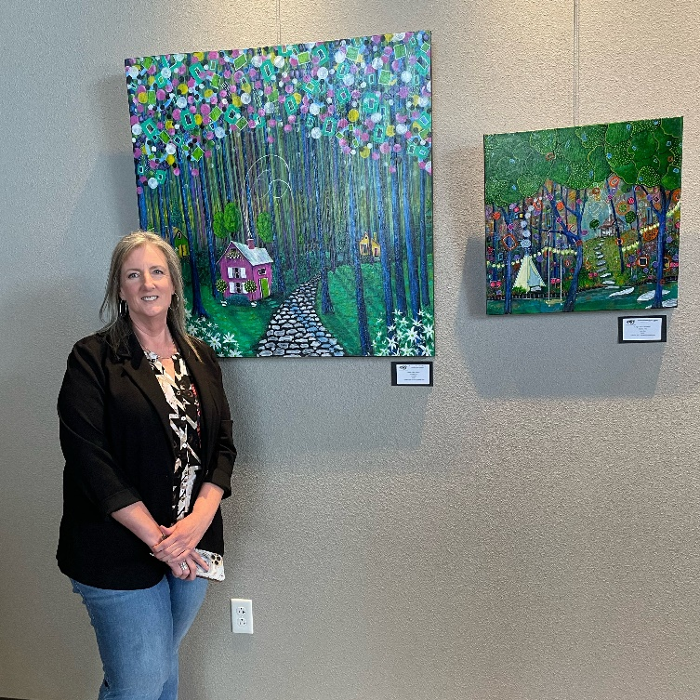
Planning ahead for upcoming shows?

July-August. No shows.

September-October. Our next show starts in September, which is also when we will start meeting at Juanita K. Hammons (because the Art Museum’s renovations will be underway). The theme for the art we hang in September is “In the Kitchen” (What’s in your Kitchen).

November-December. “Trash-Formation.” You might have already picked up a pack of materials at our April meeting, and the challenge is to transform those materials into art.

Extra Monday Meeting
We have an additional Monday meeting for those unable to attend the usual Thursday daytime meeting. We’ll meet on Monday, May 6, at Forming Art Studios, 330 South Ave., Springfield at 6 p.m. Hope to see you there!

April Meeting Recap
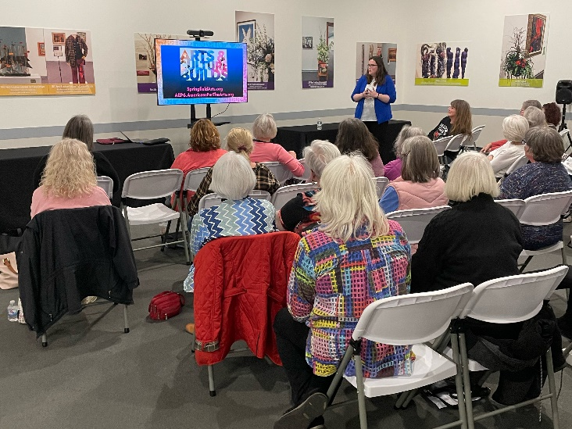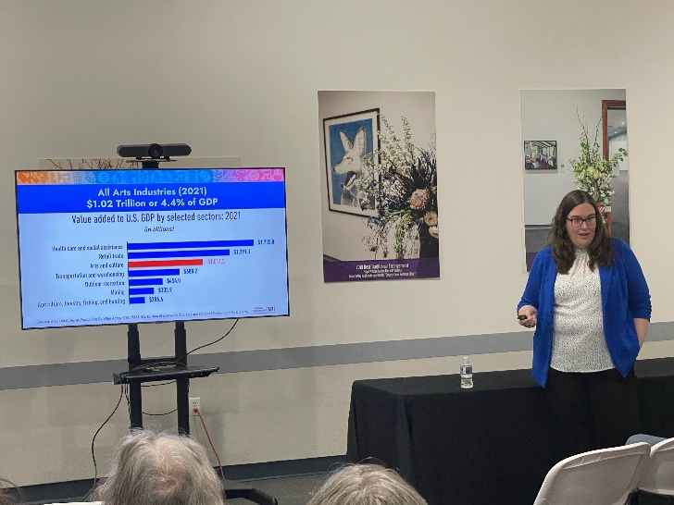
If you attended our April meeting, you heard a fact-filled presentation about the impact of arts upon the community and the economy from Leslie Forrester, Executive Director of the Springfield Arts Council. Thank you so much Leslie for putting this all in perspective for us.
Contact information for Board members is available on our website, and you can reach any of us by email to visArtsgf@gmail.com. You can also renew your membership at www.visualartistalliance.org/membership.

Dues are $25 per year, and to hang art at Juanita K. Hammons Hall or other venues through VAAS, you need to be an active member or pay an entry fee to VAAS.

