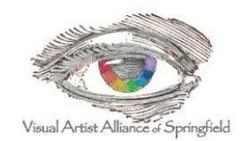
“Promoting artists and art through exhibitions, education, and fellowship.”

April Newsletter
President's Letter:

Hello artists!

Welcome Spring. It's time for plein aire or just getting outside and enjoying the spring flowers. Our new show, "Homage to a Master," reflects our favorite artists and who has influenced our work.

We have so many new helpers volunteering. The board is so grateful for more participation and the good times have rolled! Don't miss out.

We are putting together the "Trashformation" packets as we are jump-starting our creativity. Can't wait to see the results. If you have any suggestions for future projects, we welcome input.

Thursday, April 4 is a busy day for us. Pick up your pieces that were in the Senior Show that morning between 9-11 a.m. (in the Fuldner Lounge at Juanita K. Hammons), drop off your pieces for the "Homage to a Master" show on the fifth floor of Juanita K. Hammons around 10 a.m., and then we'll see you Thursday, April 4 at the Art Museum at 11 a.m. for our meeting. More information about all of that is in this newsletter, below.

Sharon Cates

April Meeting
Our Guest Speaker for our April 4 meeting: Leslie Forrester, Executive Director of the Springfield Arts Council.

Please join us at the Springfield Art Museum at 11 a.m. on April 4 for Leslie Forrester's presentation. We'll get to learn a lot about the Springfield Arts Council, the impact of arts in the community, and how members get involved to give back to the community. Leslie will also discuss her personal arts experiences.

If you have a piece of art that you would like to share or would like suggestions, please bring it to the meeting. We plan to have time for some "Show and Share" for our members.
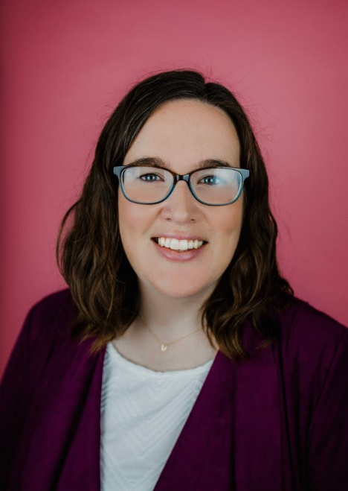
Leslie Forrester, Executive Director of the Springfield Regional Arts Council

Current and Upcoming Exhibits
“Homage to a Master"
On Thursday, April 4 at 10 a.m., members may drop off 1 or 2 pieces to be included in the 5th Floor show, "Homage to a Master" (What Artist is your Muse?). Farley Lewis will be our judge. We encourage you to bring a brief paragraph explaining your connection to the Master Artist, put on a 4x6 index card (extra index cards will be available at the meeting). The usual rules about size and preparation of art apply (must be ready for hanging or fit on a pedestal, no larger than 48 inches, etc.).

Also, if you need tags for your art, please email the following information to Ann Kynion at akynion@yahoo.com by Tuesday, April 2:
(1) Title of Work
(2) The Master Artist you are celebrating
(3) Your name
(4) Medium
(5) Price

ERPCA Show
The ERPCA show continues this month. You may see the show during business hours, and a reception for our artists and organization will be held Tuesday, April 23, from 11 a.m. to 1 p.m. The date for art pickup is April 26, from 11 a.m. to noon.

Senior Show
Of the 51 artists selected for the Senior Show at Juanita K. Hammons, 19 of those artists were current or recent VAAS members, including: Carol Chappell, Nadine Ellman, Dean Ertel, Alicia Farris ("Best of Show"), Teresa Fry ("Juror's Choice"), Deby Gilley, Ramona Gist, Chris Haik, Shae Johnson, Linda Kirchner, Ann Kynion, Paula Moore, Fletcher Neal, Andi Snethern, Doug Steere, Karen Stoner, Eleanor Strauser, Vivian Terbeek ("Fabric Art Award"), and Larry Waggoner.

Nearly Famous Deli
Don't forget to catch Nadine Ellman and Leta Sapp at Nearly Famous this month. Their show comes down on April 13th, and then the next duo of artists includes Nancy Dornan and Ann Marie Rausch.

Planning ahead for the year? Art themes for upcoming juried shows:
April/June -"Homage to a Master" (What artist is your muse?). See the description above.
July-August (no shows)
We will start meeting at Juanita K. Hammons Hall in September
September/October- "In the Kitchen" (What's in your kitchen?)
November/December - "Trash-formation" (Materials will be provided at the April 4th meeting, and there is a discussion below about this show)

Nearly Famous Deli Schedule 2024
(To participate in this show, artists commit to active membership and attendance of 4 meetings year. Qualified members' names go in a drawing at an annual meeting for a chance to participate in this sought-after event for each year.)
Celebrate our artists and support Nearly Famous!
Dec 9-Feb 10: Andi Snethern / Renee Eiffert
Feb 10-April 13: Nadine Ellman / Leta Sapp
April 13- June 8: Nancy Dornan / Ann Marie Rausch
June 8-Aug 10: Dee Giles / Karen Stoner
Aug 10- Oct 12: Carol Chappel / Carol Siano
Oct 12-Dec 14: Ann Kynion / Denise McGreevy
Dec 14- Feb 8 (2025): Peggy Gordon-Chumbley / Carol Snyder

Trash-formation!
We’ve been busy preparing the packets of materials for our November/December show, "Trash-formation." Members who choose to participate will be given 1 or 2 packets of materials to include in their art. Members who take a packet will be entered in a drawing for a few prizes at the April meeting.

In your art, you must include at least a portion of each item in the packet (each packet will have different materials, for example, scrap paper, pieces of jewelry, craft sticks, keys, and other items donated for the project). You can add your own medium (paint, paper, etc.), add your own items or "trash," and you can change the state of the materials provided (for example, paint over them, cut them, break them, etc.). Art drop-off is November 7, so you will have a lot of time to convert the materials into your own art.

We spent part of our Board meeting preparing the packets of trash-formation materials. Here's proof in a photo:
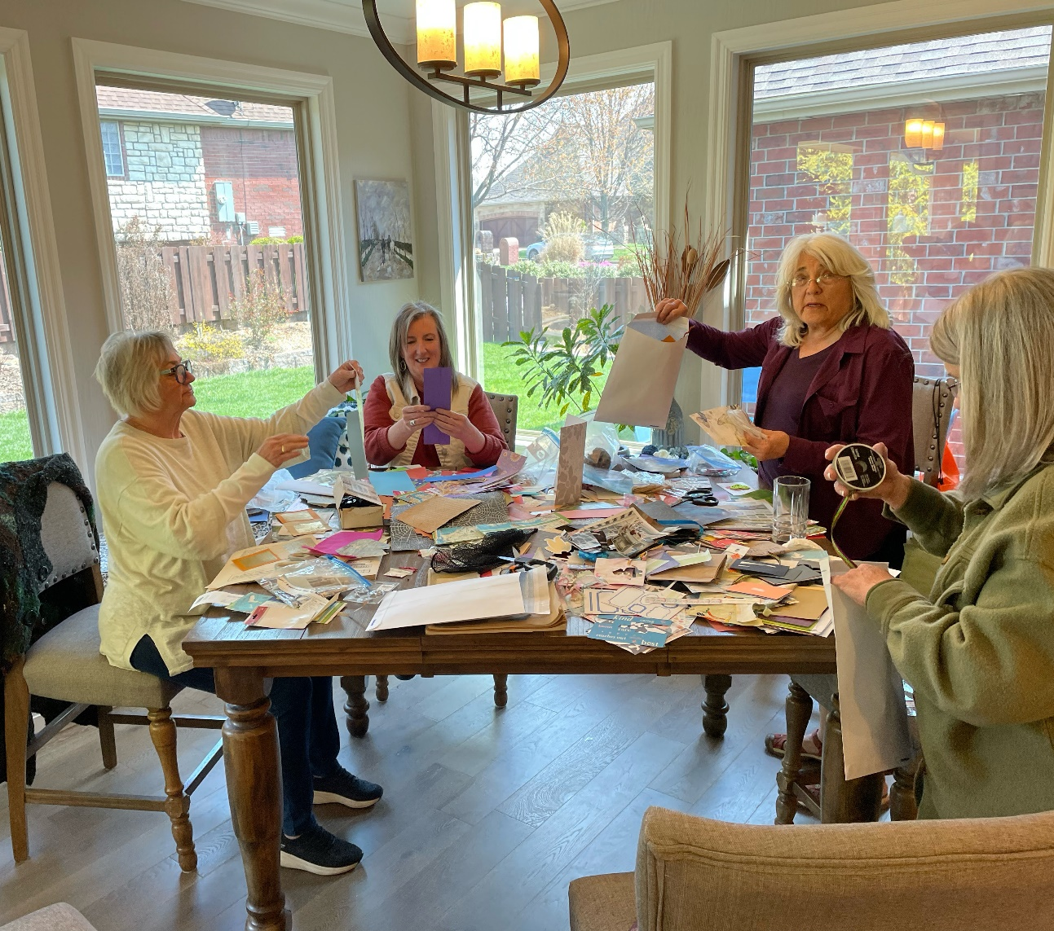

Optional Monday Meeting
We now have an additional Monday meeting for those unable to attend the usual Thursday daytime meeting, or for those who want to attend a second meeting. It's on the Monday following the usual Thursday meeting.

We discuss the previous week's speaker, VAAS's upcoming events, ideas for future events, and everyone's experiences in creating art.

We'll meet on Monday, April 8, at Forming Art Studios, 330 South Ave., Springfield at 6 p.m. Hope to see you there!

March Meeting Recap
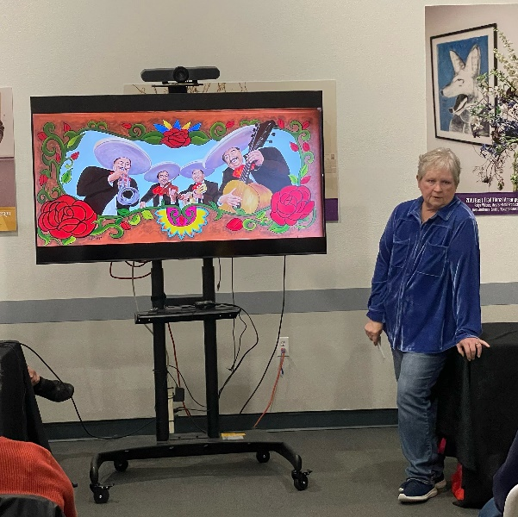
We hope you were able to join us in March for our featured speaker, Patty Rios, a long-time VAAS member and former officer. She led us on a wonderful path of all of the various types of art she has created and how it has shaped her life. Best of all, her stories were filled with her usual sense of humor.
Membership renewal online is now available.

Renew your membership dues online at www.visualartistalliance.org/membership , via mail, or at the meeting.
Or you can mail it to P.O. Box 3066, Springfield, MO 65808-3066.
Dues are $25 per year, due each December.
In order to hang art at Juanita K. Hammons Hall or other venues through VAAS, you need to be an active member or you need to pay an entry fee to VAAS.
Contacts:

President:
Sharon Cates
sharoncates38@gmail.com
417-848-7663
Vice President:
Vacancy

Secretary:
Andi Snethern
andisnethern@gmail.com
Treasurer:
Renee Eiffert
reneeeif@sbcglobal.net
417-353-8133
Nearly Famous Deli Coordinator
Dee Giles
retired245@hotmail.com
417-830-9573
Workshops/Programs
Linda Kircher
lkmom4@gmail.com
Website/Social Media
Victoria Henderson/Johnson
vljohen@gmail.com
Communications
Ann Kynion
417-848-7175
akynion@yahoo.com
Doug Steere
dougsteere@gmail.com
4th and 5th Floors Coordinator
Teresa Fry
tfryart@gmail.com

